**Chapter 1 - Quiz**

1. Which description correctly matches a router component with its function?
2. FLASH - stores the bootstrap program
3. ROM - stores the startup configuration file
4. NVRAM - stores the operating system image
5. RAM - stores the routing tables and ARP cache
6. Construct the sequence of events that occurs during the router startup process by matching one of the four step numbers to the event. (Not all options apply.)

|  |  |  |
| --- | --- | --- |
| 1. Power-on self test is conducted | ⬄ | Step 1 |
| 1. Bootstrap loader executes from ROM | ⬄ | Step 2 |
| 1. Operating system is found and loaded | ⬄ | Step 3 |
| 1. Configuration file is loaded from NVRAM | ⬄ | Step 4 |
| 1. Running-configuration is loaded from NVRAM | 🞬 |  |
| 1. Setup mode executes after configuration file is loaded | 🞬 |  |

1. Which two commands can a technician use to determine whether router serial ports have IP addresses that are assigned to them? (Choose two.)
2. show interfaces
3. show interfaces ip brief
4. show controllers all
5. show ip config
6. show ip interface brief
7. Which command sets the privileged mode password to "quiz"?
8. LAB_A(config)# enable secret quiz
9. LAB_A(config)# password secret quiz
10. LAB_A(config)# enable password secret quiz
11. LAB_A(config)# enable secret password quiz
12. Which routing principle is correct?
13. If one router has certain information in its routing table, all adjacent routers have the same information.
14. Routing information about a path from one network to another implies routing information about the reverse, or return path.
15. Every router makes its routing decisions alone, based on the information it has in its own routing table.
16. Every router makes its routing decisions based on the information it has in its own routing table and its neighbor routing tables.
17. What two tasks do dynamic routing protocols perform? (Choose two.)
18. Discover hosts
19. Update and maintain routing tables
20. Propagate host default gateways
21. Network discovery
22. Assign IP addressing
23. A network engineer is configuring a new router. The interfaces have been configured with IP addresses but no routing protocols or static routes have been configured yet. What routes are present in the routing table?
24. Default routes
25. Broadcast routers
26. Direct connections
27. No routes. The routing table is empty.
28. What two statements are correct regarding how a router forwards packets? (Choose two.)
29. If the packet is destined for a remote network, the router forwards the packet out all interfaces that might be a next hop to that network.
30. If the packet is destined for a directly connected network, the router forwards the packet out the exit interface indicated by the routing table.
31. If the packet is destined for a remote network, the router forwards the packet based on the information in the router host table.
32. If the packet is destined for a remote network, the router sends the packet to the next hop IP in the routing table.
33. If the packet is destined for a directly connected network, the router forwards the packet based on the destination MAC address.
34. If the packet is destined for a directly connected network, the router forwards the packet to the switch on the next hop V LAN.
35. Which statement is true regarding metrics used by routing protocols?
36. A metric is the quantitative value that a routing protocol uses to measure a given route.
37. A metric is a Cisco proprietary means to convert distances to a standard unit.
38. Metrics represent a composite value of the amount of packet loss occurring for all routing protocols.
39. Metrics are used by the router to determine if a packet has an error and should be dropped.
40. Metrics are only used by dynamic routing protocols.
41. Refer to the following diagram description to answer the question. A photograph of the back of a router is shown with the following interfaces identified and labeled with numbers:

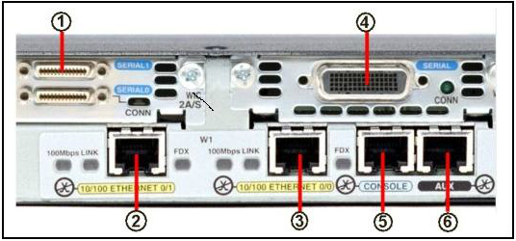

Which port is used to connect a router to a LAN switch?

1. Interface number 4
2. Interface number 5
3. Interface number 6
4. Interface numbers 1 or 4
5. Interface numbers 2 or 3
6. Interface numbers 5 or 6
7. The network administrator configured the **ip route 0.0.0.0 0.0.0.0 serial 0/0** command on the router. How does this command appear in the routing table, assuming that the serial0/0 interface is up?
8. D 0.0.0.0/0 is directly connected, Serial0/0
9. S* 0.0.0.0/0 is directly connected, Serial0/0
10. S* 0.0.0.0/0 [1/0] via 192.168.2.2
11. C 0.0.0.0/0 [1/0] via 192.168.2.2